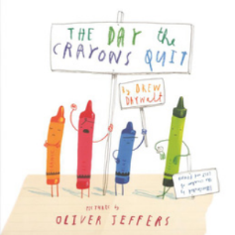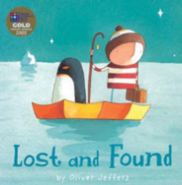 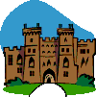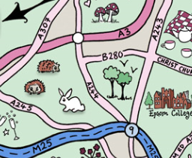

**English/Topic**

For further information on the skills taught in Year 2 please see the Curriculum Overview on the school website.

**Home Study!**

Find out about what life was like for your parents/ grandparents at school.

If possible, read any letters that come in the post (check with the person they are addressed to first) and see what they have in common or how they are different. You can bring examples to share if you like.

**Our Author Study this term is:**

Oliver Jeffers

This term maths is focussed on our knowledge and understanding of number. We will be counting; adding and subtracting using both written methods and in our heads; using our knowledge of place value and practising number facts such as number bonds.

We will be applying our knowledge of number to measure; order, represent numbers and estimate.

Where possible English lessons will be taught through topic. Our topic this half term is ‘**Hanslope Detectives**’. We will be exploring, reading and writing recounts based on our walk around the village, where we will use our geographical skills to find out about the local area and draw maps. We will also create narratives based on maps of magical worlds. We will look at the history of schools in the village, especially boarding schools and read and write letters. We will learn about Hanslope Castle and explore a range of narratives set in castles then create our own. In science we will investigate a range of materials and their uses.

We will cover a variety of English skills through these topics: focussing on: using punctuation correctly including: capital letters, full stops, exclamation marks, question marks, commas and apostrophes; spelling more accurately; beginning to join our handwriting and planning and editing our writing. We will also use a wider range of vocabulary in our writing including noun phrases and suffixes, explore different sentence types and use conjunctions to extend our sentences.

**Maths**

**Year 2 Curriculum News**