



SOCIAL NETWORKING SITES & PERSONAL INTERNET PRESENCE FOR SCHOOL STAFF

Date policy approved | 24 May 2016
Date policy reviewed
Date for next review | May 2018
Committee responsible | PPPD
Authorisation | Ryan Fensham Brown


Children & Families

Policy on Social Networking Sites & Personal Internet Presence for School Staff

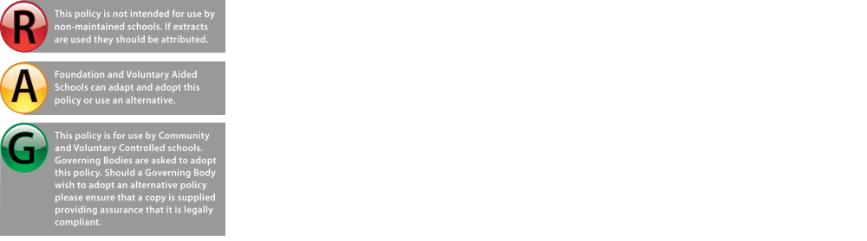

www.milton-keynes.gov.uk/mkgovernors

Date issued: February 2013
Review date: February 2015
Prepared by: Human Resources
Approved by: C&F Leadership Team
PPPD Committee – May 2016

Social Networking Sites & Personal Internet Presence for School Staff

Introduction

The purpose of this policy is to protect the reputation of employees of the school and the school as a whole from intended or unintended abuse via personal employee usage of social networking and personal internet sites.

The school recognises that such sites are increasingly useful communication tools and acknowledges the right of employees to freedom of expression. However, employees must be aware of the potential legal implications of material which could be considered abusive or defamatory and must at all times bear in mind the need to remain compliant with Milton Keynes Council’s Code of Conduct.

Definition

This policy applies to personal use of social networking sites (for example: Facebook, MySpace, Twitter, MSN, Bebo etc), personal web pages, personal space provided by internet providers and internet presence including blogs which make available personal views to the general public, including web pages or social media pages hosted by Milton Keynes Council which you are visiting as a personal user (not as a moderator).

Although LinkedIn is not primarily a social networking site employees should apply the principles set down within this policy to their use of this and similar professional networks.

Guidance
- If you already make reference to your employment at the school on a personal internet site as defined above, or you intend to create such a site, you should inform your Headteacher.
- If you do refer to your employment at the school you must use a disclaimer such as "the views contained in these web pages are my personal views and do not represent the views of the School".
- Do not use the school logo on any personal web pages.
- Please be aware that using material from any copyrighted source without permission is likely to breach copyright.
- Carefully avoid bringing the school or its employees into disrepute and consult your Headteacher if you are unsure whether the content is appropriate.
- The school reserves the right to require removal of any material published by an employee which may adversely affect the school’s reputation or create risk of legal proceedings against the school.
- Do not reveal information which is confidential to the school - consult your Headteacher if you are unsure.
- Employees must not use social networking sites for party political purposes.
- Do not include or use any school, data, information, contact details or photographs of employees, pupils, parents or partner organisations without the explicit written permission of the school and the explicit written permission of the data subject (e.g. person shown in any photograph).
- Do not include comments or photographs which could bring into question your professional credibility (directly bearing in mind Milton Keynes Council’s Code of Conduct)
- Time spent accessing social networking sites at work, for personal use, using school equipment must comply with the IT Policy applicable within the school. This includes the use of school equipment at home such as smart phones, tablets or laptops whether during or outside working hours.
- Do not invite or accept as ‘friends’ on such sites any child or vulnerable adult or the family members of any child or vulnerable adult you have met in the course of your employment.
- If you receive press or media contact regarding the content of your personal site and feel there may be implications for you or which in any way relates to the school, you should consult your Headteacher.
PPPD Committee – May 2016

Compliance
The School reserves the right to take action under the Disciplinary Policy should employees breach this policy or bring the school into disrepute by their actions on the internet. The Disciplinary Policy is available on the Internet at: Disciplinary Policy applicable to Headteachers or Disciplinary Policy applicable to School Staff other than Headteachers

Employees must ensure that their use of social networking sites does not breach the safeguarding guidance as set out in Section 12 of the Guidance for Safer Working Practice for Adults who work with Children and Young People in Education Settings available on the Department for Education website.

Employee privacy and dignity

Employees are strongly recommended to check that their online privacy settings only allow “friends” to see their profiles and that the privacy settings of “friends” do not inadvertently allow access to the employee’s own profile. It is also advised that as a general measure to protect their personal safety and identity, staff do not accept friend requests from people who are not personally known to them.

Employees may wish to ask friends to check before photographs are posted which may cause them embarrassment. Employees posting their own images should bear in mind the fact that any image can easily be downloaded and manipulated and they should choose which images they share accordingly. It is recommended that employees do not post images that could be used to identify their homes or families.

Information and training

All employees are advised to make themselves familiar with the parent/carer or teacher/trainer pages on the CEOP “Think You Know” site at www.thinkyouknow.co.uk

A full days training can also be accessed via www.mkscb.org which incorporates the CEOP internet safety training and information on grooming via the internet. There is no charge for this course. The MKSCB website also provides links to other e-safety information as well as the full inter-agency safeguarding training programme.

Safety of Young People

Employees should be aware of the vulnerability of young people on line. Employees who use social media within their work to contact young people should:-
- Always be professional and maintain the highest standards of personal behaviour at all times
- Recognise the trust that is placed in adults by children and treat this trust with the highest respect and responsibility
- Work in an open and accountable manner at all times
- Always use appropriate language and be respectful in any communication
- Not favour or appear to favour any child or show interest in one more than another
- Not discriminate against anyone because of age gender, disability, culture, language, ethnicity, religious beliefs or sexual identity
- Be aware that children may misinterpret your intentions, so ensure that all language is age appropriate

www.milton-keynes.gov.uk/mkgovernors
Milton Keynes Council
Saxon Court
502 Avebury Boulevard
Central Milton Keynes
MK9 3HS
T 01908 253851
F 01908 253867
E declan.leith@milton-keynes.gov.uk
W www.milton-keynes.gov.uk

