1. Type ttrockstars.com into your browser’s address bar.
2. Log in. (School Name – Hanslope Primary School)

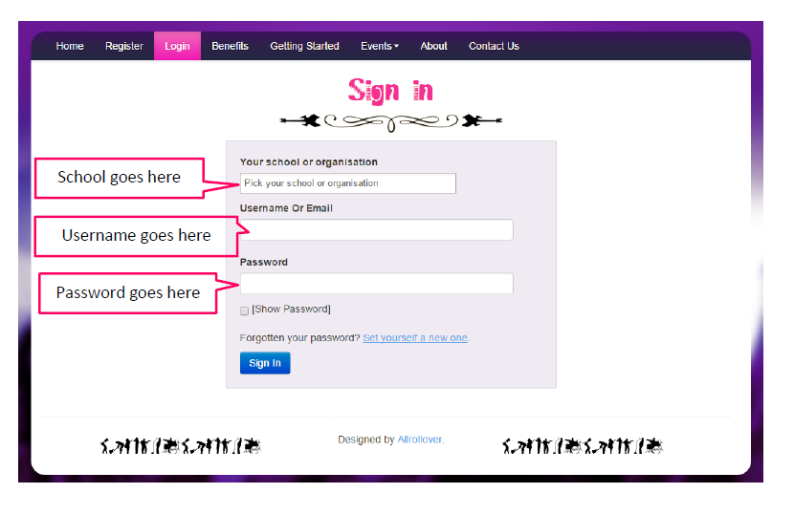
3. Each child will need to create their own avatar and choose a rock star name.

4. Play! There are 4 different game modes, which you can find out about below.

N.B. Please visit the app store to download the Times Tables Rock Stars apps on Android and Apple.

Game Modes
Single Player

Garage - the questions will only come from the times tables the teacher has set for the week. As pupils start to answer questions, TT Rock Stars works out which facts they take longer on and will give them more of these questions to answer. The Garage is best for getting quicker at a few facts. Players get 10 coins per question.

Studio - the questions in the Studio can be anything from 1×1 up to 12×12. TT Rock Stars calculates each the mean speed from their last 10 games in the Studio and translates into a Rock Status:

≤ 1 sec/qu = Rock Hero  ≤ 2 secs/qu = Rock Legend  ≤ 3 secs/qu = Rock Star  ≤ 4 secs = Headliner  ≤ 5 secs/qu = Support Act  ≤ 6 secs/qu = Breakthrough Artist | ≤ 7 secs/qu = Unsigned Act  ≤ 8 secs/qu = Gigger  ≤ 9 secs/qu = Busker  ≤ 10 secs/qu = Garage Rocker  > 10 secs/qu = Wannabe

They earn 1 coin per question and the Studio is the place for them to set their best time across all the tables.

Multiplayer

Rock Arena - The Arena allows players to compete against all other members of their Band (their Bandmates would need to join the same game in order to compete together). A new Arena game starts every 15 seconds and once the clock starts they race to answer more questions than the others. In the Arena, questions will only come from the times tables the teacher has set for the week, similar to the Garage. They earn 1 coin per correct answer.

Rock Festival - The Rock Festival games are open to players from around the world. Like the Arena, there is no limit to the number of players who can join a game; however, unlike the Arena, questions are selected at random from 1×1 to 12×12. Pupils might choose the Rock Festival if they were playing at home (and therefore couldn't easily synchronise playing against a classmate) or wanted to compete against others not in their Band. They earn 1 coin per correct answer.

The times tables to practice

Here are the National Curriculum Objectives for times tables:
Year 1 – Count in multiples of 2,5 and 10
Recall and use all doubles to 10 and corresponding halves
Year 2 – recall and use multiplication and division facts for the 2, 5 and 10 multiplication tables including recognising odd and even numbers
Year 3 – Recall and use the multiplication and division facts for the 3,4 and 8 multplication tables
Year 4 – Recall and use the multiplication and division facts for multiplication tables up to 12x12
Year 5 – Revision of all times tables and division facts up to 12 x 12
Year 6 – Revision of all times tables and division facts up to 12 x 12
Please bear in mind that each school, each class and each child is different.

Stats

If you click on Me > My Stats, a heatmap like the one below will load. It shows how successful your child is at each of the facts.

Questions, Problems, Suggestions
Contact your class teacher
• You have username or password issues
• Something isn’t working or you’re not sure how it works
• You have a complaint or a suggestion
• You have something nice to say about ttrockstars.com!

Enjoy!

