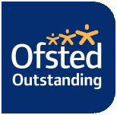

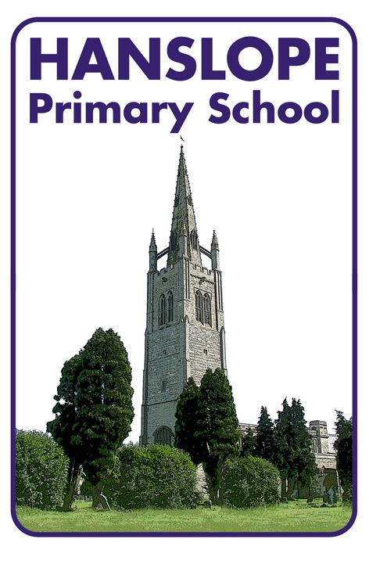

EARLY YEARS FOUNDATION STAGE
(EYFS) POLICY

Date policy approved | January 2013
Date policy reviewed | February 2016
Date for next review | Febuary 2017
Committee responsible | Curriculum
Authorisation | Ryan Fensham-Brown

Early Years Foundation Stage Policy

The Early Years Foundation Stage (EYFS) applies to children from birth to the end of the reception year. In our school all children join us part time and gradually become full time before the end of the first term.

The EYFS is based upon four principles:
- A Unique Child
- Positive Relationships
- Enabling Environments
- Learning and Development

A Unique Child
At Hanslope School we recognise that every child is a competent learner who can be resilient, capable, confident and self assured. We recognise that children develop in individual ways, at varying rates. Children’s attitudes and dispositions to learning are influenced by feedback from others; we use praise and encouragement, as well as celebrating and rewarding, to encourage children to develop a positive attitude to learning.

Inclusion
We value the diversity of individuals within the school and do not discriminate against children because of ‘differences’. All children at Hanslope are treated fairly regardless of race, religion or abilities. All children and their families are valued within our school.
In our school we believe that all our children matter. We give our children every opportunity to achieve their best. We do this by taking account of our children’s range of life experiences when planning for their learning.
In the EYFS we set realistic and challenging expectations that meet the needs of our children.
We meet the needs of all our children through:
- planning opportunities that build upon and extend children’s knowledge, experience and interests, and develop their self-esteem and confidence;
- using a wide range of teaching strategies based on children’s learning needs;
- providing a wide range of opportunities to motivate and support children and to help them to learn effectively;
- providing a safe and supportive learning environment in which the contribution of all children is valued;
- using resources which reflect diversity and are free from discrimination and stereotyping;
- planning challenging activities for children whose ability and understanding are in advance of their language and communication skills;
- monitoring children’s progress and taking action to provide support as necessary.

It is important to us that all children in the school are ‘safe’. We aim to educate children on boundaries, rules and limits and to help them understand why they exist. We provide children with choices to help them develop this important life skill. Children should be allowed to take risks, but need to be taught how to recognise and avoid hazards.
We aim to protect the physical and psychological well being of all children (see whole school Safeguarding Children Policy).

Welfare
At Hanslope School we understand that we are legally required to comply with certain welfare requirements as stated in the Statutory Framework for Early Years Foundation Stage. We understand that we are required to:
- Promote the welfare of children.
- Promote good health, preventing the spread of infection and taking appropriate action when children are ill.
- Manage behaviour effectively in a manner appropriate for the children’s stage of development and individual needs.
- Ensure all adults who look after the children or who have unsupervised access to them are suitable to do so.
- Ensure that the premises, furniture and equipment is safe and suitable for purpose
- Ensure that every child is provided with opportunities for enjoyable and challenging learning and development experiences tailored to meet their needs.
- Maintain records, policies and procedures required for safe efficient management of the setting and to meet the needs of the children.
- Paediatric First Aid certificates are held by at least one adult within the EYFS setting.

Positive Relationships
At Hanslope School we recognise that children learn to be strong, independent and form secure relationships. We aim to develop caring, respectful, professional relationships with the children and their families.

Parents as Partners
We recognise that parents are children’s first and most enduring educators and we value the contribution they make.
We recognise the role that parents have played, and their future role, in educating the children. We do this through:
- talking to parents about their child before their child starts in our school
- the teacher offers to visit all children in their home setting or at school prior to their starting school
- the children have the opportunity to spend time with their teacher before starting school
- inviting all parents to an induction meeting during the term before their child starts school
- encouraging parents to support their child’s learning
- encouraging parents to talk to the child’s teacher if there are any concerns
- arranging a range of activities throughout the year that encourage collaboration between child, school and parents: parent tasks, sports days etc
- encouraging and providing opportunities for parents to communicate their child’s achievements outside of school

All staff involved with the EYFS aim to develop good relationships with all children, interacting positively with them and taking time to listen to them. Each pupil within EYFS is assigned a ‘Key Worker’, which is either the class teacher or the Teaching Assistant.

Enabling Environments

The curriculum the Early Years Foundation Stage (EYFS) follow is outlined in the following document which can be downloaded by following this link: https://www.gov.uk/government/uploads/system/uploads/attachment_data/file/335504/EYFS_framework_from_1_September_2014__with_clarification_note.pdf

This clearly defines what we teach.

At Hanslope School we recognise that the environment plays a key role in supporting and extending the children’s development. This begins by observing the children and assessing their interests, development and learning, before planning challenging but achievable activities and experiences to extend the children’s learning.

Observation, Assessment and Planning
The EYFS comprises of three Prime Areas and four Specific Areas of learning. The Prime Areas begin to develop quickly in response to children’s relationships and experiences. The Prime areas continue to be fundamental throughout the Foundation stage.

Prime Areas
- Personal, Social and Emotional Development
- Communication and Language
- Physical Development.

Specific Areas
- Literacy
- Mathematics
- Understanding the World
- Expressive Art and Design

The Specific areas grow from the Prime areas and provide important contexts for learning. Children must be secure in the Prime areas in order to achieve well in the Specific areas.

We recognise that none of these areas can be delivered in isolation from the others. They are equally important and depend on each other. All areas are delivered through a balance of adult led and child initiated activities. In each area there are Early Learning Goals (ELG's) that define the expectations for most children to reach by the end of the EYFS.

Long and medium term plans are devised and these plans are used by the EYFS teacher as a guide for weekly planning. However the teacher may alter these plans in response to the needs (achievements and interests) of the children. We make regular assessments of children’s learning and we use this information to ensure that future planning reflects identified needs. Assessment in the EYFS takes the form of observation, and this involves the teacher and other adults as appropriate. These observations are recorded using ‘2build a profile’; an app on an iPad. Virtual post it notes are written and tagged with the learning objective. These observations are then saved on a web management suite. This enables evidence to be gathered for each childs’ EYFS profile

The Learning Environment
The EYFS classroom is organised to allow children to explore and learn securely and safely. The classroom is set up in learning areas, where children are able to find and locate equipment and resources independently. The EYFS class has it own enclosed outdoor area. We plan activities and resources for the children to access outdoors that help the children to develop in all the Prime and Specific areas of learning.

Learning and Development
At Hanslope School we recognise that children learn and develop in different ways and at different rates. We value all areas of learning and development equally and understand that they are interconnected.

Teaching and Learning Style
Our policy on Teaching and Learning defines the features of effective teaching and learning in our school. These features apply to teaching and learning in the EYFS just as much as they do to the teaching in Key Stage 2. Features that relate to the EYFS are:

- the partnership between teachers and parents, so that our children feel secure at school and develop a sense of well-being and achievement;
- the understanding that teachers have of how children develop and learn, and how this affects their teaching;
- the range of approaches used that provide first-hand experiences, give clear explanations, make appropriate interventions and extend and develop play and talk or other means of communication;
- the carefully planned curriculum that helps children work towards the Early Learning Goals throughout EYFS;
- the provision for children to take part in activities that build on and extend their interests and develop their intellectual, physical, social and emotional abilities;
- the encouragement for children to communicate and talk about their learning, and to develop independence and self-management;
- the support for learning with appropriate and accessible indoor and outdoor space, facilities and equipment;
- the identification of the progress and future learning needs of children through observations, which are shared with parents;
- the good relationships between our school and the settings that our children experience prior to joining our school;

Playing and exploring
Through play our children explore and develop learning experiences, which help them make sense of the world. They practise and build up ideas and learn how to control themselves and understand the need for rules. They have the opportunity to think creatively alongside other children as well as on their own. They communicate with others as they investigate and solve problems. They become engaged in activities and are willing to “have a go.”

Active Learning
Active learning occurs when children are motivated and interested. Children need to have some independence and control over their learning. As children develop their confidence they learn to make decisions. It provides children with a sense of satisfactions as they take ownership of their learning.
Children become motivated to keep trying and seek approval and praise when they achieve what they set out to do.

Creativity and Thinking Critically
We endeavor to give children opportunities to be creative through all areas of learning, not just through the arts. Adults can support children’s thinking and help them to make connections by showing genuine interest, offering encouragement, clarifying ideas and asking open questions. The children can access resources freely and are allowed to move them around the classroom to extend their learning. We encourage the children to have their own ideas in all aspects of their learning, whilst offering constructive feedback so that they are able to evaluate their achievements and facilitate further learning.

